Has the iPod made us anti-social?
By Tom de Castella
BBC News Magazine
- 27 September 2011
- From the section Magazine
- comments
*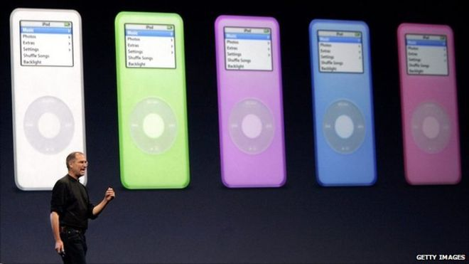
It's 10 years since the iPod was unveiled, but has the MP3 player turned us all into headphone-wearing, anti-social people?
It sounds like a dystopian* vision. Half of humankind wired up to a parallel universe* that leaves them oblivious to their surroundings and fellow man.
Those used to travelling on public transport will recognise the scene - a carriage full of commuters sprouting white wires that plug into the ear with little white buds. In the car, children listen to their own music on headphones.
Once upon a time footballers* travelling to away games would bond over a game of cards on the team bus. Now they step off the coach with headphones on, as if their journey has been a solitary exploration of a favourite playlist or movie. Many runners, cyclists and even swimmers train with headphones.
By 2007 over half of Western city dwellers were using an iPod or MP3 player, says Prof Michael Bull, author of Sound Moves: iPod culture and urban experience.
It has gone beyond the anti-establishment youth market of the personal stereo to embrace everyone from children to grandparents. And research suggests that when people switch to an MP3 player, they listen to music for twice as long as before, Prof Bull says.
Leander Kahney, editor of Cultofmac.com, based in San Francisco, argues the iPod has enriched people's lives, allowing them to escape the daily grind. "It's been a great boon to people on the way to work. There's nothing like music to be a mood lifter. The iPod is a mood drug."
Here Thierry Henry has his headphones in the "you may talk to me" position
So ubiquitous* is headphone culture today that it has become a sort of cultural shorthand - often for a spoilt, selfish generation who lack civic values.
(adapted from “Has the IPOD made us anti-social?” by Tom de Castella
- A dystopia is an imaginary community or society that is undesirable or frightening. It is literally translated as "not-good place", an antonym of utopia.
- A parallel universe is a hypothetical self-contained separate reality co-existing with one's own.
- Footballers another name for Soccer Players
- Ubiquitous an adjective that means present, appearing, or found everywhere.

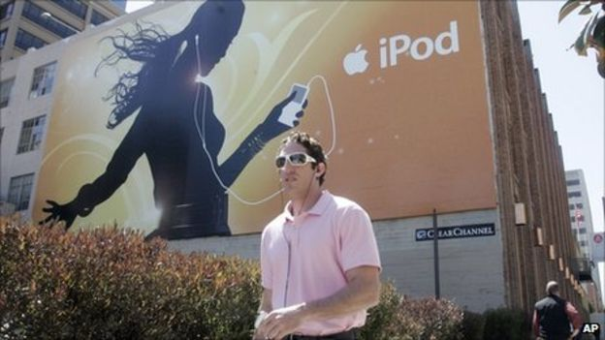The MP3 player dominates the Western world
But the iPod hasn't caused this move from public to personal space, it is just reflecting the trend, Prof Bull argues. Nowadays people work out to their own playlists in the gym rather than hearing the same tunes. But that's not to say people are becoming anti-social.
"The actual presence of people next to you in the street is not recognised as social any more. We get our intimacy from nearby loved ones or people who are absent over chat sites and social media," he says.
Pavel says he never set out to isolate people from the outside world when he made that first rudimentary personal stereo. Indeed he recalls how his patent suggested a non-recording microphone so that users could hear the world around them during the music. And there were to be up to four outputs so that people could listen in groups.
In the end, it's a trade-off, Pavel believes. Sometimes we want privacy and escapism, other times interaction with our fellow man.
"It is somewhat isolating. But when I'm on the bus I don't necessarily want to talk to people. I want the aesthetic involvement of listening to music."

