Magazine | THE MEDIUM

Against Headphones
By VIRGINIA HEFFERNAN
JAN. 7, 2011
Photo
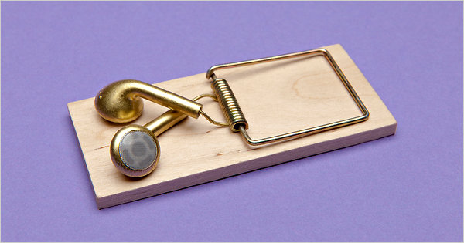
Credit Photograph by Kevin Van Aelst

One in ﬁve teenagers in America can’t hear rustles or whispers, according to a study published in August in The Journal of the American Medical Association. These teenagers exhibit what’s known as slight hearing loss, which means they often can’t make out consonants like T’s or K’s, or the plinking of raindrops. The word “talk” can sound like “aw.” The number of teenagers with hearing loss — from slight to severe — has jumped 33 percent since 1994.

Given the current ubiquity of personal media players — the iPod appeared almost a decade ago — many researchers attribute this widespread hearing loss to exposure to sound played loudly and regularly through headphones. (Earbuds, in particular, don’t cancel as much noise from outside as do headphones that rest on or around the ear, so earbud users typically listen at higher volume to drown out interference.) Indeed, the August report reinforces the findings of a 2008 European study of people who habitually blast MP3 players, including iPods and smartphones. According to that report, headphone users who listen to music at high volumes for more than an hour a day risk permanent hearing loss after five years.
Photo
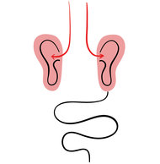
CreditIllustrations by Olimpia Zagnoli

Maybe the danger of digital culture to young people is not that they have hummingbird attention spans but that they are going deaf.
Most discussions of the transformation of music by digital technology focus on the production end. But headphones transform sound for the consumer too. Headphones are packed with technology. When an audio current passes through the device’s voice coil, it creates an alternating magnetic field that moves a stiff, light diaphragm. This produces sound. If you think about all the recordings, production tricks, conversions and compressions required to turn human voices and acoustic instruments into MP3 signals, and then add the coil-magnet-diaphragm magic in our headphones, it’s amazing that the intensely engineered frankensounds that hit our eardrums when we listen to iPhones are still called music.
Whatever you call it, children are listening to something on all these headphones — though “listening” is too limited a concept for all that headphones allow them to do. Indeed, the device seems to solve a real problem by simultaneously letting them have private auditory experiences and keeping shared spaces quiet. But the downside is plain, too: it’s antisocial. As Llewellyn Hinkes Jones put it not long ago in The Atlantic: “The shared experience of listening with others is not unlike the cultural rituals of communal eating. Music may not have the primal necessity of food, but it is something people commonly ingest together.”
Headphones work best for people who need or want to hear one sound story and no other; who don’t want to have to choose which sounds to listen to and which to ignore; and who don’t want their sounds overheard. Under these circumstances, headphones are extremely useful — and necessary for sound professionals, like intelligence and radio workers — but it’s a strange fact of our times that this rarefied experience of sound has become so common and widespread. In the name of living a sensory life, it’s worth letting sounds exist in their audio habitat more often, even if that means contending with interruptions and background sound.
Make it a New Year’s resolution, then, to use headphones less. Allow kids and spouses periodically to play music, audiobooks, videos, movie, television and radio audibly. Listen to what they’re listening to, and make them listen to your stuff. Escapism is great, and submission and denial, too, have their places. But sound thrives amid other sounds. And protecting our kids’ hearing is not just as important as protecting their brains; it is protecting their brains.

(adapted from Magazine | THE MEDIUM Against Headphones by Virginia Hefferman)

