No More “Hit and Run” Quotations:
Selecting and Using Evidence Effectively in Argument

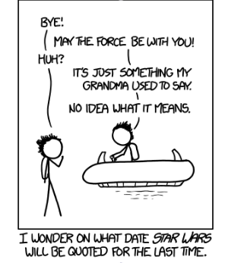
www.xkcd.com/1262 “Unquote”

Melissa Bergeman
SAWP Advanced Institute 2015

Rational (5 min)
One of the largest difficulties for students and teachers is the use of quotations and specific evidence in papers. For the students, they see it as a burden--having to research and select such pieces of evidence--and for the teachers, it is a difficult thing to grade because it is often done ineffectively. Too many times, when told they must include evidence in their papers, students commit what can be called “‘hit-and-run quotation.’” (Graff and Birkenstein, 44). These quotations are dropped into the paragraph with little to no introduction or explanation.
The even larger struggle is to then teach students how to go about selecting relevant, powerful, and meaningful evidence in their papers. After all, “to launch an argument you need to write the arguments of others into your text” (Graff and Birkenstein, 42). At the heart of an academic, and therefore argumentative piece of writing, an essential element is to integrate into the new piece what others have already theorized. This is true for writing in the sciences, social sciences, and humanities. However, in the secondary classroom, it is becoming essential with the implementation of the Common Core State Standards. Students are expected to generate their own writings but also use those of others, particularly to give their arguments authority and credence (Graff and Birkenstein, 42).
Students need to first have an idea of what they are writing about before they can select evidence--a task that is significantly more directed when students are working with a given set of texts, rather than an open-ended research task. Once they have a direction, they can then select the evidence that best supports the “text at a particular point where you insert them” (Graff and Birkenstein, 43). After selecting quotations, students need to respond to the text and not simply leave quotations sprinkled throughout their paper. An argument is built step by step, and half of each step is using a relevant and targeted piece of evidence.
To build the other half of the step, students need to explain the reasons that the evidence supports their argument. Ultimately, they should end up with a “quote sandwich,” where they introduce who drafted the original piece of evidence, give the evidence, and then respond with their own ideas about the evidence (Graff and Birkenstein, 46). By building their papers in this way, they integrate not only the ideas of others, but also their own--which is Illustrating, one of the key Harris Moves to argument writing (Sproul and Wendler, SAWP 2015). Using the adapted dialectical journal helps students rank their evidence, thus teaching them to think through the process of selection, and then working them through the steps of explaining that thinking so it can easily be worked into the paper (Shumake, SAWP 2014).

Sloth Racing on Trial: Locating and Using the Best Quotes (30 minutes)

Students will use a fake criminal case where they can take sides, evaluate evidence, and then present their chosen pieces of evidence in an argument for either the prosecution or defense. A jury of peers will then decide a verdict of guilty or not guilty based on the arguments presented.

1. Draw a notecard--based on the color you receive, move into the correct groups.
2. Do not open your group’s envelope until told to do so!
3. Using the giant graphic organizer, begin organizing the pieces of evidence as a group as per the following (10 mins):
- Of the given pieces of evidence, each group chooses up to 3 to include in their final argument.
- Rank each chosen piece of evidence based on its quality on a scale of 1-3 (1 being best), and place on the appropriate box.
- Using a marker, explain why this piece of evidence supports your group’s case for the prosecution or the defense.
- Draft a claim for your prosecution or defense team.
4. Present cases to the Jury: Prosecution and Defense. Hand evidence charts to the jury when done (10 min).
5. Jury Deliberation: Come to a consensus of guilty or not guilty by explaining your rationale based on the evidence presented and creates a chart of the most persuasive pieces of evidence (10 min).

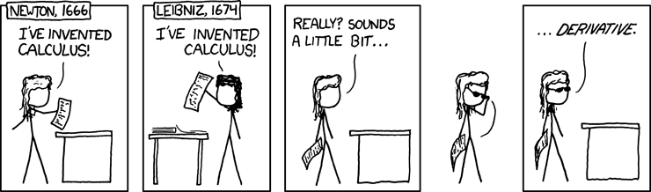

http://xkcd.com/626/ “Newton and Liebniz”

Building An Argument: Reading, Annotating, and Generating Ideas (25 min)
1. Chose one of the following two claims below, circle it, and read the article that accompanies your chosen claim.
2. Read your article -- select no more than five pieces of evidence per article.
3. Rank your pieces of evidence from your article 1-5 (1 being best), and fill in the chart below.
Feel free to add horizontal lines as you finish to make your chart most organized for you.

Claim: Disney Princesses break gender stereotypes (How Disney Princess Culture…)
Disney Princesses reinforce gender stereotypes (What’s Wrong with Cinderella)

Rank Quotation Reason Evidence Supports Claim

Drafting: Applying Evidence and Writing a Paragraph (15 min)
Using the space provided, or a piece of your own paper, draft a full paragraph. Be sure to include a topic sentence and concluding sentence. You may or may not choose to use all of the evidence you have selected as long as you have a strong, concrete paragraph.

Check Your Evidence: Bring on the Color! (10 min)
Trade paragraphs with a partner. Use the highlighters to highlight the specific parts of your partner’s paragraph:
- Claim: Yellow/Orange
- Evidence: Green/Blue
- Explanation of Evidence: Pink

Did you have mostly one color or another in your paragraph? What color did you have the most, and which the least? Which should be the most prominent color?

Works Cited
Graff, Gerald, and Cathy Birkenstein. ""As He Himself Puts It: The Art of Quoting." They Say / I Say: The Moves That Matter in Academic Writing. New York: W.W. Norton, 2010. 42-51. Print.
Various strategies and methods for teaching academic writing across various subject areas. This book has a focus on all levels of argument writing - the relevant chapter dealt with the need for including quotations and source evidence in academic writing.
Shumake, Jessica. “Dialectical Thinking.” Southern Arizona Writing Project 2014, June 18, 2014. Presentation.
Teaching demo that illustrated various ways for students to engage with text and merge writing with different means of dialogue and thinking.
Sproul, Cathy and Rachel Wendler. “Harris Moves.” Southern Arizona Writing Project: Advanced Institute 2015, June 6, 2015. Presentation
Presentation outlining the four basic moves in argument writing.

Academic Standards
Reading: Cite strong and thorough textual evidence to support analysis of what the text says explicitly as well as inferences drawn from the text, including determining where the text leaves matters uncertain. (11‐12.RL.1)

Writing: Write arguments to support claims in an analysis of substantive topics or texts, using valid reasoning and relevant and sufficient evidence - Develop claim(s) and counterclaims fairly and thoroughly, supplying the most relevant evidence for each while pointing out the strengths and limitations of both in a manner that anticipates the audience’s knowledge level, concerns, values, and possible biases. (11-12.W.1)

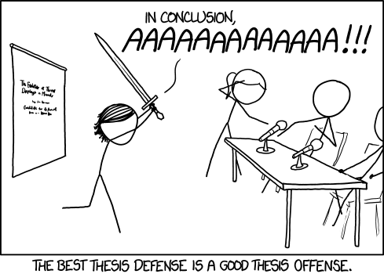
http://xkcd.com/1403/ “Thesis Defense”

Sloth Racing Evidence

Each group receives the same list, regardless of Prosecution or Defense. Place evidence in closed envelopes, and have each team get one envelope.

Used syringes, which tested positive for steroids, were found in the trash can next to Lightning’s cage at the racetrack.
Three years ago, McGee was disciplined for administering steroids to Lightning. Lightning’s victories were forfeited, and Lightning was banned from racing for the rest of the season.
The previous record, .017 MPH, was shattered in the first race of the year by Lightning, who clocked .025 MPH.
LIghtning has baldness and fur loss--common side effects of steroid use in sloths.
Lightning has injection scars on his hips and back of the next.
McGee’s internet search history included “steroids,” “strength increase,” and “stamina increase.”
McGee’s competitor, Florence Simon, testifies that McGee has a “shifty, guilty appearance” before each race.
McGee has a prized jester hat, the trophy from one of Lightning’s victories, that is missing a bell. Lightning jingles when racing.

An empty bottle of caffeine was found in McGee’s home.
Lightning’s vet, Dan Drury, asserts that steroids are very dangerous for diabetic sloths--it usually results in a dangerous and potentially deadly insulin crash. Lightning is diabetic.
Lightning’s father, Thunder, completed the Molasses Derby in 4 days, 13 hours, and 27 seconds.
Lightning’s mother, Rain, can carry 6 lbs on her back. Lightning can carry 4 lbs. The average sloth can carry 5 lbs.
Lightning helped an injured sloth, belonging to competitor Florence Simon, in the previous race, losing and placing second.
Pet psychic Sarah C. Voyant spoke to Lightning, and says that he told her, “I do not use steroids.”

Sample Color Paragraph

To improve efficiency, especially during emergencies, all buildings over three stories tall should be install zip lines. This will improve speed and efficiency during emergency evacuations. For example, according to Burning University’s study on evacuation times, stairwells often become clogged during evacuation. This can happen for a variety of reasons, such as smoke and flames, to the sheer number of people trying to use the stairwell at the same time. With ziplines, and a simple accessory provided to each employee, everyone can now safely exit the building in a timely manner during an emergency. Practice evacuations will train employees in the proper and safe use of the ziplines will establish procedure so that people exit the building with little panic. For those terrified of heights, they can still exit the building in the same traditional manner.

