THE NEW YORKER
JUNE 20, 2012
An Offer to Laugh You Can’t Refuse
BY ROBERT MANKOFF

When thinking about New Yorker cartoons, I don’t think the word “offensive” often comes to mind. Or at least to most minds. But offensiveness, like love, is in the eye of the beholder, and there are enough eyes eying The New Yorker that even cartoons that seem innocuous can trigger outrage. Consider the example below. For most people, of whatever age, this cartoon is gently amusing, and the elderly gent in the cartoon appears slightly bemused as well.
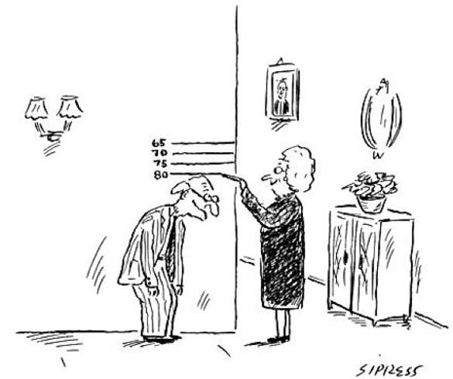

‬ But we did get this response:
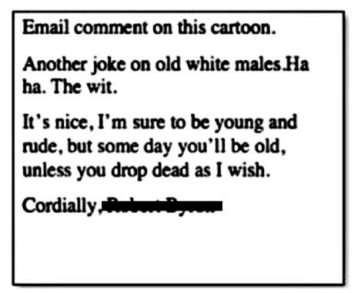

I would find that comment personally offensive if I took it literally, but I did not. By ironically concluding his missive, “Cordially,” Mr. Name Redacted indicated that his message was in jest. Most of the time, our readers have no problem not taking our cartoons literally; they easily distinguish the typecasting in cartoons, which is innocuous, from real-world stereotyping, which isn’t.

For example, readers don’t infer from the following cartoon that The New Yorker, or the cartoonist Michael Maslin, really believes that the police employ a good-cop, bad-cop strategy in interrogating suspects. And in order to laugh at the joke, readers only have to know that the good-cop, bad-cop genre exists.
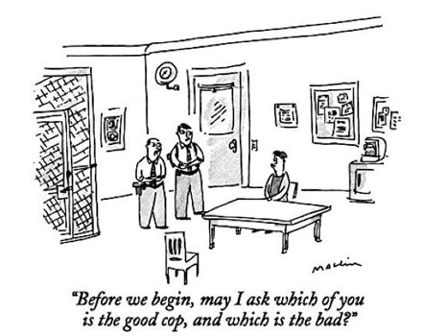
In the same way, for cartoon purposes, the default mob family is always Italian, even though that ethnic group has never had a mob monopoly.
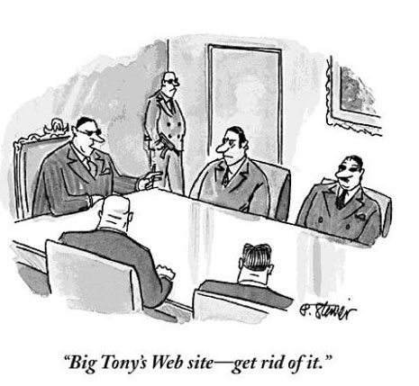
The Irish, the Jews, the Russians, and the Chinese have all had their mobs. Nevertheless, substituting “Big Sean” or “Big Irving” or “Big Boris” or “Big Ming” for “Big Tony” in the above caption just won’t work.

Some humor theorists, holding to what is called the “salience hypothesis,” extend this mob-equals-Italians reasoning to justify disparaging jokes against groups that have been traditionally disadvantaged. The idea being that understanding a stereotype doesn’t mean endorsing it. These same theorists point to research showing that hearing derogatory jokes about, for instance, lawyers doesn’t negatively influence a subject’s attitudes towards lawyers. Thank goodness! That would be the final nail in the coffin for those poor downtrodden lawyers.

Other humorologists oppose this view. They point to studies showing that disparagement humor which uses stereotypes found in racist and sexist jokes is enjoyed partly because it enables people to express negative attitudes in a socially acceptable manner. In last week’s article about Seth MacFarlane, the creator of “Family Guy” owns up to pushing the limits of what’s acceptable to make fun of, saying, “If I’m really being honest, then maybe there’s a part of me that’s stuck in high school and we’re laughing because we’re not supposed to.”
Well, if part of us weren’t stuck in high school, there would be a lot less laughter in the world, and Seth MacFarlane wouldn’t have a comedy empire. Is the source of much humor rooted in the puerility of prejudice or, as I see it, in an adult appreciation of absurdity?

Robert Mankoff is an American cartoonist and author, and current cartoon editor for The New Yorker

http://www.newyorker.com/from-the-desk-of-bob-mankoff/an-offer-to-laugh-you-cant-refuse

